AKASH KUMAR BANIK
24MCA0242
DATE: 16-12-2024

2. HTML IMAGE EXERCISES
a. Display five different images. Skip two lines between each image. Each image should have a title.
CODE:
<!DOCTYPE html>
<html lang="en">
<head>
<meta charset="UTF-8">
<meta name="viewport" content="width=device-width, initial-scale=1.0">
<title>Document</title>
</head>
<body>
<img src="img1.png" alt="Imgae1" title="This is Ubuntu Logo1" height="350em"><br>
<label for="img">This is Ubuntu Logo</label>
<br><br><br>
<img src="img1.png" alt="Imgae1" title="This is Ubuntu Logo1" height="350em"><br>
<label for="img">This is Ubuntu Logo</label>
<br><br><br>
<img src="img1.png" alt="Imgae1" title="This is Ubuntu Logo1" height="350em"><br>
<label for="img">This is Ubuntu Logo</label>
<br><br><br>
<img src="img1.png" alt="Imgae1" title="This is Ubuntu Logo1" height="350em"><br>
<label for="img">This is Ubuntu Logo</label>
<br><br><br>
<img src="img1.png" alt="Imgae1" title="This is Ubuntu Logo1" height="350em"><br>
<label for="img">This is Ubuntu Logo</label>
<br><br><br>
</body>
</html>

OUTPUT:
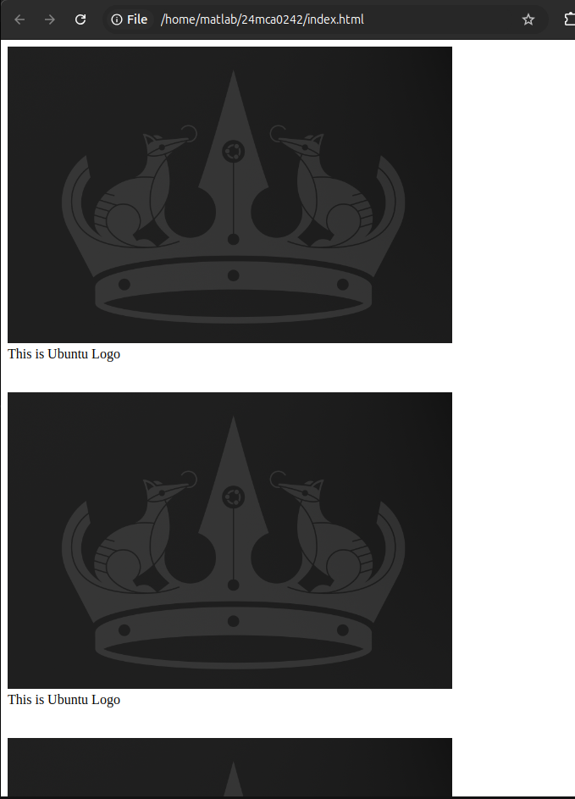
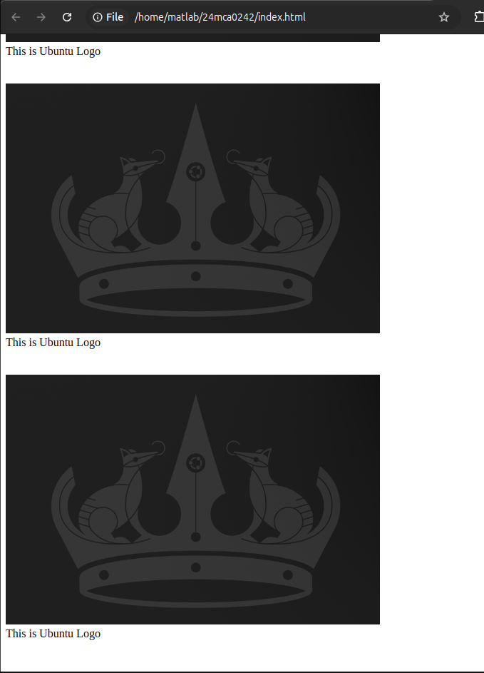
b. Display an image that has a border of size 2, a width of 200, and a height of 200.

CODE:
<!DOCTYPE html>
<html lang="en">
<head>
<meta charset="UTF-8">
<meta name="viewport" content="width=device-width, initial-scale=1.0">
<title>Document</title>
</head>
<body>
<img src="img1.png" alt="Imgae1" width="200" height="200" style="border: 2px blue solid;"><br>
<label for="img">This is Ubuntu Logo</label>
<br><br><br>
</body>
</html>

OUTPUT:
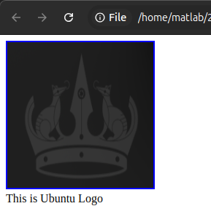

c. Display the image towards the right corner of the webpage

CODE:
<!DOCTYPE html>
<html lang="en">
<head>
<meta charset="UTF-8">
<meta name="viewport" content="width=device-width, initial-scale=1.0">
<title>Document</title>
<style>
img{
border: 5px blue solid;
float: right;
}
</style>
</head>
<body>
<img src="img1.png" alt="Imgae1" width="200" height="200"><br>
</body>
</html>

OUTPUT:

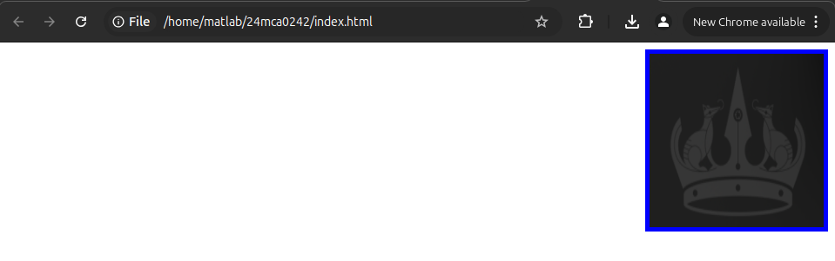
gds

3. HTML LIST EXERCISES
I. Program to illustrate Nested ordered list and Definition lists
a. Solid gray banner along the top of the browser window
i. company logo
ii. product image

b. A text-based navigation menu
i. Links to each of the site’s web documents

c. A content area
i. A heading that identifies page content
ii. A paragraph for displaying content
iii. A copyright notice

II. Create the following list using HTML.
CODE
<!DOCTYPE html>
<html lang="en">
<head>
<meta charset="UTF-8">
<meta name="viewport" content="width=device-width, initial-scale=1.0">
<title>Document</title>
<style>
h1{
text-align: center;
}
</style>
</head>
<body>
<h1>To illustrate Nested and Definition List Tags</h1>
<hr size="5px" color="darkgrey">
<h2>An Ordered List</h2>
<ol type="1">
<li>Cofee</li>
<li>Tea
<ol type="a">
<li>Black Tea</li>
<li>Green Tea
<ol type="i">
<li>China</li>
<li>Africa</li>
</ol>
</li>
</ol>
</li>
<li>Milk</li>
</ol>

<h2>A Definition List</h2>
<dl>
<dt>Bangalore</dt>
<dd>-Capital City of Karnataka</dd>
<dt>Mumbai</dt>
<dd>-Capital Cityof Maharashtra</dd>
</dl>
</body>
</html>

OUTPUT

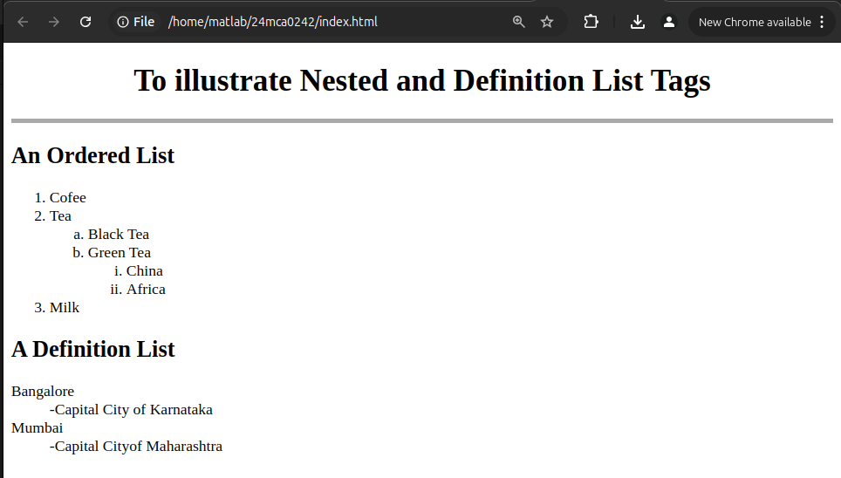

III. Create the following list using HTML tags
CODE
<!DOCTYPE html>
<html lang="en">
<head>
<meta charset="UTF-8">
<meta name="viewport" content="width=device-width, initial-scale=1.0">
<title>Document</title>
<style>

</style>
</head>

<body>
<h2>List Examples</h2>
<hr size="5px" color="darkgrey">

<p>This is an unordered list</p>
<ul>
<li>List Item 1</li>
<li>List Item 2</li>
<li>List Item 3</li>
</ul>

<p>This is an ordered list</p>
<ol>
<li>List Item 1</li>
<li>List Item 2</li>
<li>List Item 3</li>
</ol>

<p>This is an ordered list starting at 10 and in upper-case roman numerals</p>
<ol type="I" start="10">
<li>List Item 1</li>
<li>List Item 2</li>
<li>List Item 3</li>
</ol>

<p>This is an unordered list nestewd within an ordered list</p>
<ol>
<li>Walk the dog</li>
<li>Wash the car</li>
<li>Get groceries
<ul>
<li>Gound beef</li>
<li>Mozzarella</li>
<li>Lasagna Noodles</li>
<li>Pasta Sauce</li>
<li>Ricotta Cheese</li>
</ul>
</li>
<li>Clean the house</li>
<li>Take out garbage</li>
</ol>
</body>
</html>

OUTPUT

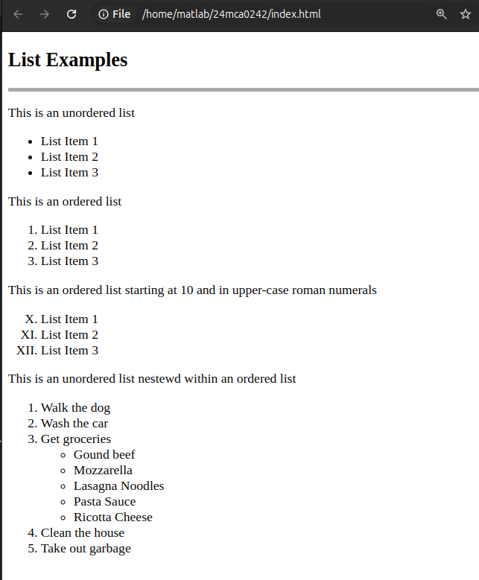

4. HTML TABLE EXERCISES
Create the following tables using HTML code.
A. Pick 5 company stocks and hunt down their current stock prices.
i) Place them in a neatly arranged table with their name, symbol, last price, 52wk high, 52wk low and PE ratio.
ii) The end result should look like the following. Notice that the first column is aligned left and the rest are centered.

CODE
<!DOCTYPE html>
<html lang="en">
<head>
<meta charset="UTF-8">
<meta name="viewport" content="width=device-width, initial-scale=1.0">
<title>Document</title>
<style>
table,tr,td,th{
border: 5px salmon solid;
border-collapse: collapse;
padding: 10px;
}
.left{
text-align: left;
}

</style>
</head>

<body>
<h2>TABLE Examples</h2>
<hr size="5px" color="darkgrey">

<table>
<tr>
<th colspan="6"><i>My tech stock picks</i></th>
</tr>

<tr>
<th class="left">NAME</th>
<th>SYMBOL</th>
<th>CURRENT</th>
<th>52WK HIGH</th>
<th>52WK LOW</th>
<th>P/E RATIO</th>
</tr>

<tr>
<td>Microsoft</td>
<td>MSFT</td>
<td>86-3/8</td>
<td>119-15/16</td>
<td>75-1/2</td>
<td>56.09</td>
</tr>

<tr>
<td>Cisco Systems</td>
<td>CSCO</td>
<td>72-1/8</td>
<td>82</td>
<td>24-13/16</td>
<td>400.69</td>
</tr>

<tr>
<td>America Online</td>
<td>AOL</td>
<td>63</td>
<td>95-13/16</td>
<td>38-15/32</td>
<td>350.00</td>
</tr>

<tr>
<td>Qwest Communications</td>
<td>Q</td>
<td>44-7/16</td>
<td>66</td>
<td>25-3/4</td>
<td>74.06</td>
</tr>

<tr>
<td>Dell Computers</td>
<td>DELL</td>
<td>53-59/64</td>
<td>59-11/16</td>
<td>31-3/8</td>
<td>86.97</td>
</tr>
</table>

</body>
</html>

OUTPUT

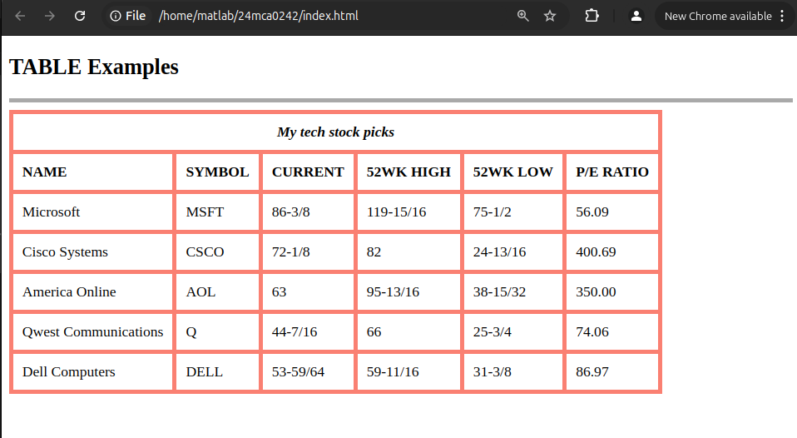

iii) Now alter the last table with dashed line with red color.

CODE
<!DOCTYPE html>
<html lang="en">
<head>
<meta charset="UTF-8">
<meta name="viewport" content="width=device-width, initial-scale=1.0">
<title>Document</title>
<style>
table,tr,td,th{
border: 5px salmon solid;
border-collapse: collapse;
padding: 10px;
text-align: center;
}
.left{
text-align: left;
}

</style>
</head>

<body>
<h2>TABLE Examples</h2>
<hr size="5px" color="darkgrey">

<table>
<tr>
<th colspan="6"><i>My tech stock picks</i></th>
</tr>

<tr>
<th class="left">NAME</th>
<th>SYMBOL</th>
<th>CURRENT</th>
<th>52WK HIGH</th>
<th>52WK LOW</th>
<th>P/E RATIO</th>
</tr>

<tr>
<td class="left">Microsoft</td>
<td>MSFT</td>
<td>86-3/8</td>
<td>119-15/16</td>
<td>75-1/2</td>
<td>56.09</td>
</tr>

<tr>
<td class="left">Cisco Systems</td>
<td>CSCO</td>
<td>72-1/8</td>
<td>82</td>
<td>24-13/16</td>
<td>400.69</td>
</tr>

<tr>
<td class="left">America Online</td>
<td>AOL</td>
<td>63</td>
<td>95-13/16</td>
<td>38-15/32</td>
<td>350.00</td>
</tr>

<tr>
<td class="left">Qwest Communications</td>
<td>Q</td>
<td>44-7/16</td>
<td>66</td>
<td>25-3/4</td>
<td>74.06</td>
</tr>

<tr style="border: 5px blue dotted;">
<td class="left" style="border: 5px blue dotted;">Dell Computers</td>
<td style="border: 5px blue dotted;">DELL</td>
<td style="border: 5px blue dotted;">53-59/64</td>
<td style="border: 5px blue dotted;">59-11/16</td>
<td style="border: 5px blue dotted;">31-3/8</td>
<td style="border: 5px blue dotted;">86.97</td>
</tr>
</table>

</body>
</html>

OUTPUT

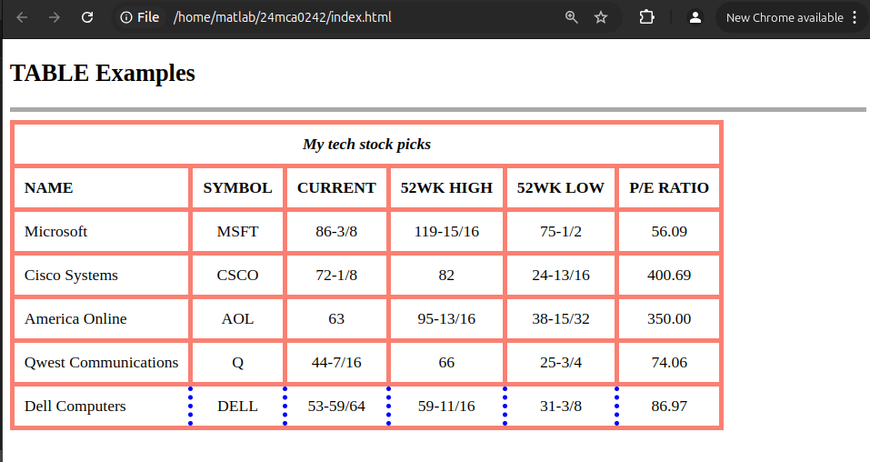

B. List of Fruits
CODE

<!DOCTYPE html>
<html lang="en">
<head>
<meta charset="UTF-8">
<meta name="viewport" content="width=device-width, initial-scale=1.0">
<title>Document</title>
<style>
table,tr,td,th{
border: 5px black solid;
border-collapse: collapse;
padding: 10px;
text-align: center;
width: 80%;
}

</style>
</head>

<body>
<h2>TABLE Examples</h2>
<hr size="5px" color="darkgrey">

<table>
<tr>
<th colspan="2"><i>Fresh Fruits</i></th>
</tr>

<tr>
<td>It has long been known that a diet that includes at least a few servings of fresh fruit every day will help keep you healthy, fit and trim</td>
<td><img src="img1.png" alt="ubuntu logo" height="100px"></td>
</tr>

</table>

</body>
</html>

OUTPUT

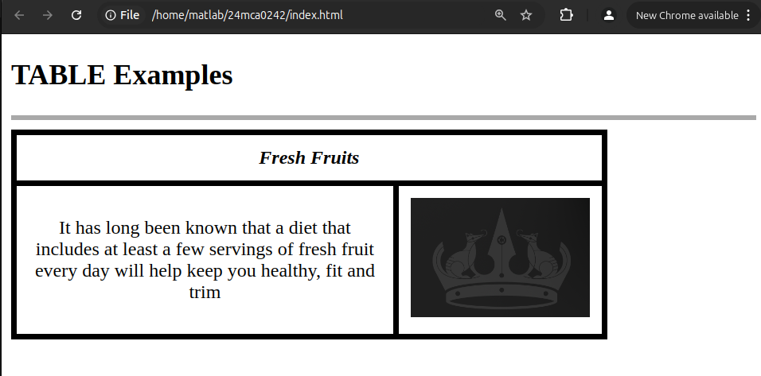

6. HTML FORM EXERCISES
B.

2.
CODE:
<!DOCTYPE html>
<html lang="en">
<head>
<meta charset="UTF-8">
<meta name="viewport" content="width=device-width, initial-scale=1.0">
<title>Document</title>
<link rel="stylesheet" href="style.css">
</head>
<body>
<a href="index.html" target="_blank">Cascading Style Sheet</a>

</body>
</html>
OUTPUT:
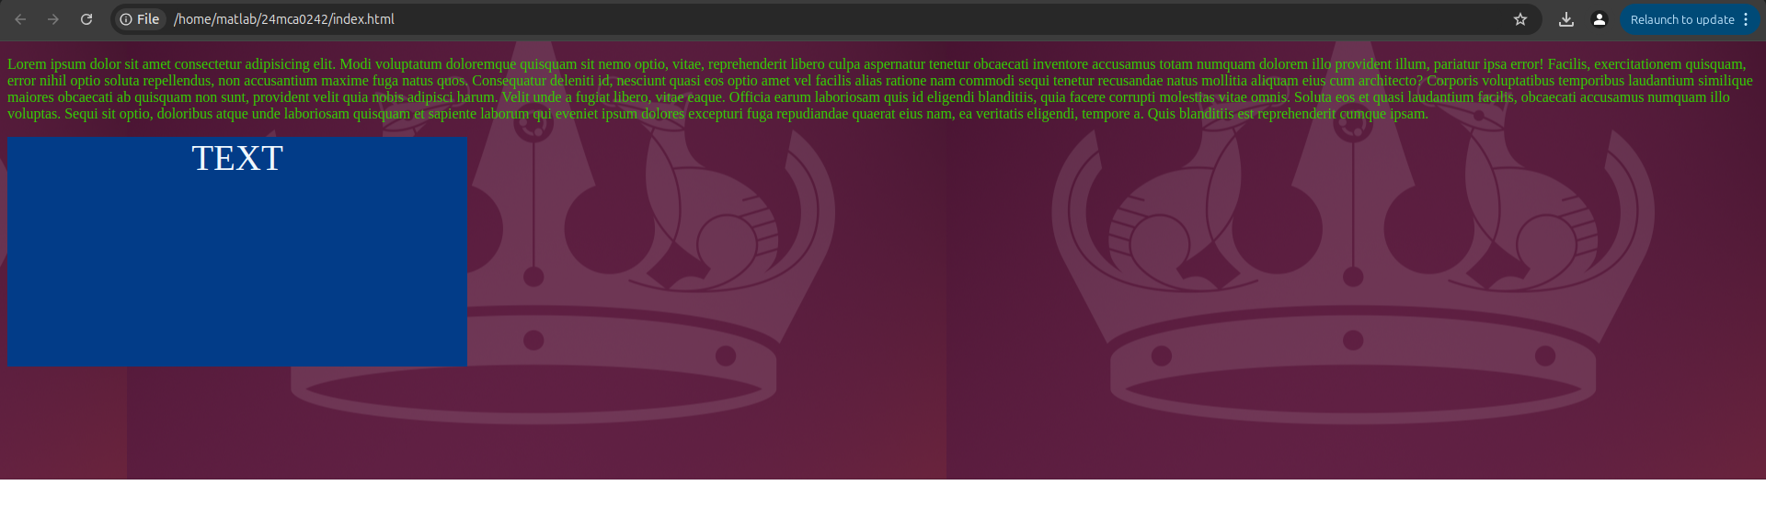

3.
CODE:
<!DOCTYPE html>
<html lang="en">
<head>
<meta charset="UTF-8">
<meta name="viewport" content="width=device-width, initial-scale=1.0">
<title>Document</title>
<link rel="stylesheet" href="style.css">
</head>
<body>
<a href="index.html" target="_blank">Cascading Style Sheet</a>

</body>
</html>
OUTPUT:

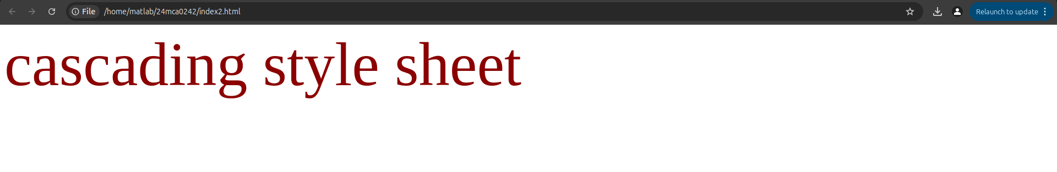

4.
CODE:
<!DOCTYPE html>
<html lang="en">
<head>
<meta charset="UTF-8">
<meta name="viewport" content="width=device-width, initial-scale=1.0">
<title>Document</title>
<style>
body{
background-color: coral;
}
p{
margin-top: 100px;
margin-right: 40%;
font-family: 'Times New Roman', Times, serif;
font-style: italic;
font-size: 30px;
color: lime;
border-right: 5pt #CC99CC groove;
border-top: 10px #99CCCC groove;
border-left: 2cm #CCCC99 groove;
border-bottom: 1cm #C9C9C9 groove;
letter-spacing: 2px;
text-decoration: line-through;
}

</style>
</head>

<body>
<p>"Now paragraphs can have a border of their own"</p>

</body>
</html>

OUTPUT:
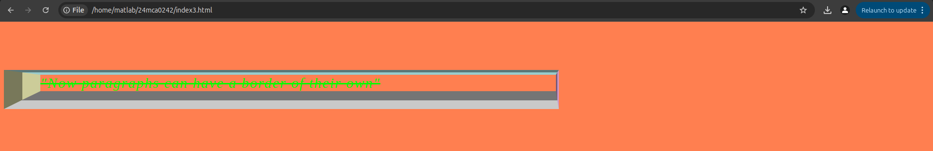
5.
CODE:
<!DOCTYPE html>
<html lang="en">
<head>
<meta charset="UTF-8">
<meta name="viewport" content="width=device-width, initial-scale=1.0">
<title>Document</title>
<style>
img{
border-top: 3px dashed green;
border-bottom: 3px dashed green;
border-left: 5px solid green;
border-right: 5px dashed green;
}

</style>
</head>

<body>
<img src="image1.png" alt="">

</body>
</html>
OUTPUT:

